Are your details correct?  To help us keep our records up to date,  please complete the form below with any  updated details in BLOCK CAPITALS | 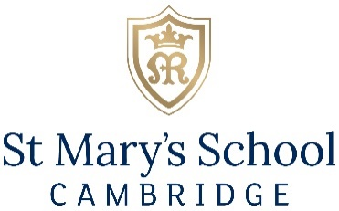

Updated Address:
Preferred
Email:
Preferred Phone:
Job Title:
Company:
Profession:

How would you like us to communicate with you?
You may be aware that data protection regulations are due to change and St Mary’s School is seeking your confirmation regarding how you would like us to communicate with you. As a St Mary’s School alumnae, we very much want to ensure you are kept informed about celebrations and news, and receive invitations to reunions and events.
All your details are treated confidentiality and with sensitivity. Data is held securely and will be used solely by St Mary’s School and our representatives for School and alumni activities.
St Mary’s School Privacy Notice can be found at: http://www.stmaryscambridge.co.uk/privacy-policy.htm
The Data Protection Policy is on the School website at:
http://www.stmaryscambridge.co.uk/ugc-1/1/12/0/data_protection_policy.pdf

It is really important that you let us know if you wish to receive St Mary’s School news, invitations, fundraising initiatives and other communications, and your preference for our communication.
Please ensure we have updated details and tick all that apply:
Post |  | Email |  | Telephone

Signature: __________________________________________ Date: ____________________________
If you would like to unsubscribe, and no longer wish to receive any event and marketing communication from St Mary’s School, please do let us know by post, by email to ewhittley@stmaryscambidge.co.uk or by calling the office on 01223 224126
Please return this form in the enclosed freepost envelope (for UK only)
or using the following address:
The Development Office
St Mary’s School, Bateman Street,
Cambridge CB2 1LY, Cambridgeshire, UK

